Melbet: Taxonomy Profile
Taxonomy Factor | Classification
Name | Melbet (also written MelBet): offshore online sportsbook and casino
Candidate Class | Offshore/unlicensed bookmakers (T6). Also fits cricket and fantasy-sports wagering, esports wagering, and online casino as facets
Primary Audience | Adult bettors, with cricket and IPL markets and local payment methods aimed at South Asian markets such as India and Bangladesh
Gambling Connection | Direct. Real-money sports betting and casino games with cash payout
Addiction / Harm Score | 9/10: Very High
Risk Score | 9/10: Very High
Tier Classification | T6: unlicensed or offshore real-money wagering (Australia and India)
Financial Score | 9/10: Very High
Monetary Value | Real cash (including INR, BDT and cryptocurrency) deposited and withdrawable, subject to operator terms
Regulatory Status | Claims a Curaçao licence (the number differs between sources and is unverified; see Section 2); no Australian licence. Online money games are prohibited in India under the 2025 Act, in force since 1 May 2026 (Lexology, 2026; Press Information Bureau, 2026); Bangladesh is described as a legal grey area (Football Whispers, 2026); an Australian Communications and Media Authority (ACMA) site search for Melbet returned no results, which is weak evidence of non-blocking (ACMA, n.d.)

1. Melbet
Melbet is an international online bookmaker and casino, reported to have been founded in 2012. It offers sports betting including cricket and IPL markets, live betting, a casino of thousands of games and crash games such as Aviator, all under one account (Telecom Asia, n.d.; Football Whispers, 2026). Its core function is gambling, and the app is reported to be distributed as a direct download rather than through an app store (Football Whispers, 2026).

2. Description and Connection to Gambling
Review sites describe Melbet as operating in more than 100 countries, with 180-plus crash games such as Aviator among its casino offering (Telecom Asia, n.d.; Football Whispers, 2026). It is reported to accept UPI and Paytm in India, local payment systems in Bangladesh and cryptocurrency (Telecom Asia, n.d.; The Hans India, 2025; Goal.com India, 2026).
The operator claims a Curaçao licence, but sources give different licence numbers (8048/JAZ2020-060 in one review and OGL/2024/561/0554 in another) (Football Whispers, 2026; The Hans India, 2025). One review names the operating company as Pelican Entertainment B.V. and notes that a Curaçao licence gives weaker player protection than licences from regulators such as those of the UK, Malta, Sweden or Denmark (BetLuma, 2026). Another commercial source attributes the licence-number difference to Curaçao's licensing reform of 24 December 2024 (Allaxess, 2026); that explanation is itself unverified. Nearly all Melbet-specific sources are commercial review sites, some with affiliate links (BetLuma, 2026), so their statements are recorded as claims, not verified facts. Licensing, ownership, and payout claims are still to be independently verified by registration and regulatory notices and independent reporting by the Curaçao Gaming Authority.
Gambling Connection: Direct. Melbet is a real-money gambling site and covers the gambling sector of both sports and casino.

3. Age Group and Addiction Risk
Target age group: Adults who bet. Both the cricket and IPL markets and local payment methods suggest that the primary target market is South Asian bettors (Telecom Asia, n.d.; The Hans India, 2025). A broader audience is targeted through football, tennis, basketball, and kabaddi markets (Football Whispers, 2026).
Addiction / Harm Score: 9/10: Very High. The score will be increased if the following features are present:
- Football Whispers (2026) and Telecom Asia, n.d. note that real money is available on all bets, with live betting and crash games offering the possibility of quick betting again.
- Very large casino library, with more than 5,000 games under one account, and also offering sports betting (Telecom Asia, n.d.).
This is a taxonomy assessment drawing on published research on gambling harm (Langham et al., 2016), not a clinical diagnosis.

4. Risk or Danger
Risk Level: Very High: 9/10.
- Legal status in India. The Promotion and Regulation of Online Gaming Act 2025 bans online money games (both skill-based and chance-based), extends to services operated outside of India and prohibits their advertising (Lexology, 2025; International Masters of Gaming Law [IMGL], 2026; Promotion and Regulation of Online Gaming Act 2025). Goal.com India (2026) describes Melbet as safe for Indian players because it is offshore, but that claim conflicts with the reach of this Act and should not be repeated without consulting a lawyer. The Act and its Rules entered into force on 1 May 2026 but, according to the Press Information Bureau (2026) and Lexology (2026), a judicial challenge against the Act was reported to be pending.
- Legal status elsewhere. According to one review, Bangladesh can be described as a legal grey area with regard to offshore betting (Football Whispers, 2026). A real-money wagering service is unlicensed if it does not have an Australian licence under the project’s tier rule. When searching for Melbet on the ACMA site, no results appeared, but this does not necessarily mean that it is not blocked, as the site search is not the blocked-sites register, so the absence is weak evidence and the register should be consulted directly (ACMA, n.d.).
- Withdrawal disputes (unverified). Melbet pages on Trustpilot show reviews alleging delayed and refused withdrawals, alongside Melbet’s responses asking the reviewers to reach out to support and positive reviews (Trustpilot, 2026a, 2026b). The www.melbet.com page has been given a Trustpilot integrity warning (rating withheld after fake reviews have been deleted), which means that the reviews on the page cannot be relied upon either way. These are not findings, but allegations made by users.
- The Android version of the app is downloaded directly from the operator's website in APK file format, avoiding app stores, according to a review from Football Whispers (2026).

5. Tier Classification
Tier: T6: Unlicensed or Offshore Real-money Wagering.
Classification path:
Melbet → local-payment or crypto deposit → sports bets and casino games → cash withdrawal (bank, e-wallet, crypto) → offshore operator with no Australian licence; prohibited online money game in India → T6
Note for the taxonomy: Melbet is an offshore bookmaker, a cricket wagering platform, and an online casino. A clear example of the need for the taxonomy to be faceted, not hierarchical, and why a claimed licence should not, in isolation, move an operator from T6 to T5.

6. Harm: Financial Harm and Psychological Harm
Financial Score: 9/10: Very High
Financial harm. Losses are actual cash, and if the operator is offshore, then a player does not have an Australian or Indian complaint mechanism (ACMA, 2024, for Australian illegal operators). Withdrawals are said to not be processed or are being refused (Trustpilot, 2026a, 2026b), but this is not verified. Cryptocurrency payment methods are disclosed (Goal.com India, 2026); It is generally difficult to reverse a crypto payment. As part of the seven harm categories, financial harm is identified by Langham et al. (2016).
Psychological harm. There was no evidence specific to Melbet about psychological harm. Emotional and psychological harm are included in a seven-category taxonomy of gambling-related harm outlined by Langham et al. (2016), and relationship, health, work or study harm, and harm from criminal acts are identified. The latter applies in the context of the present issue, as participation in a banned money game is legally liable in India.

7. Monetary Value
Monetary Value - Real Cash in, Real Cash out (bank, e-wallet, cryptocurrency)
Cash-out pathways:
- Payment methods that have been reported to have been used include bank transfers, e-wallets like Skrill, and cryptocurrency (Goal.com India, 2026); UPI and Paytm in India (Telecom Asia, n.d.); and local Bangladeshi systems with a reported minimum withdrawal of 500 BDT and a stated maximum processing time of 24 hours (The Hans India, 2025).
- Fast payment is a claim made by review sites which is countered by user allegations of delays, contesting the reliability of the pathway (Trustpilot, 2026a, 2026b). The tier does not indicate that cash comes out reliably; it indicates that cash, in theory, can come out.

8. Evidence as Images
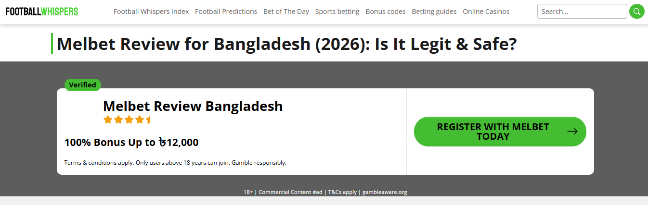 | 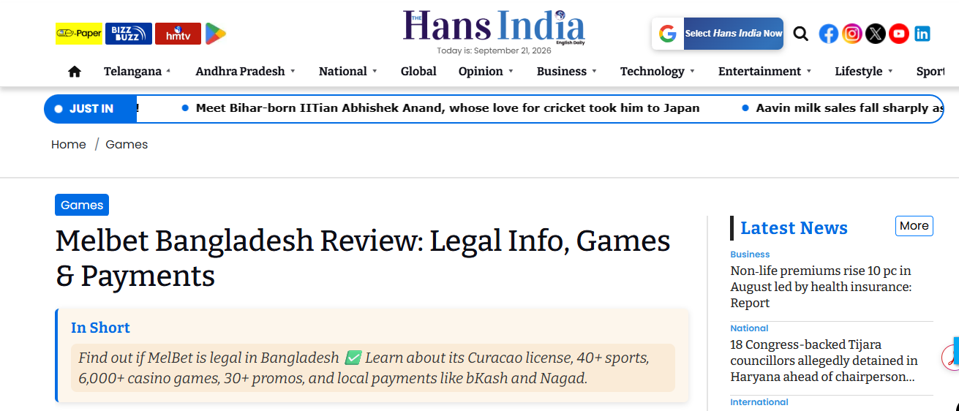
Figure 17: Football Whispers Melbet review page, marked as commercial content (#ad) | Figure 18: The Hans India Melbet Bangladesh review summary (Curaçao licence, games and local payments)
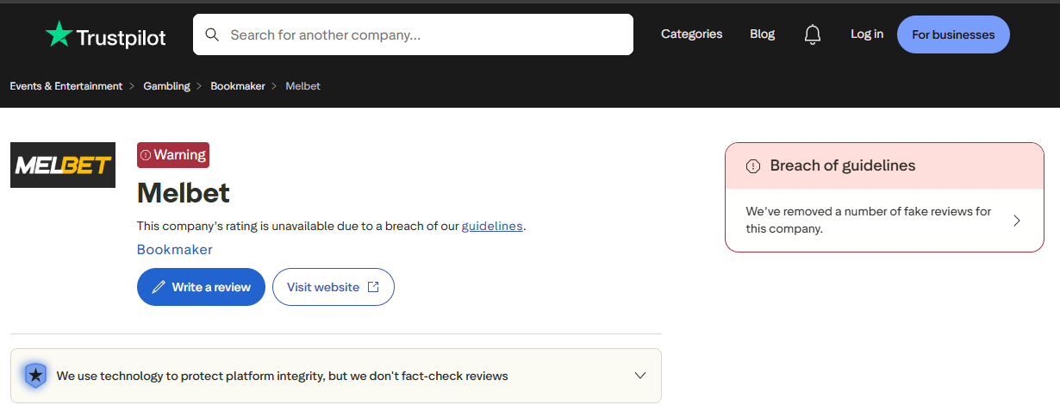 | 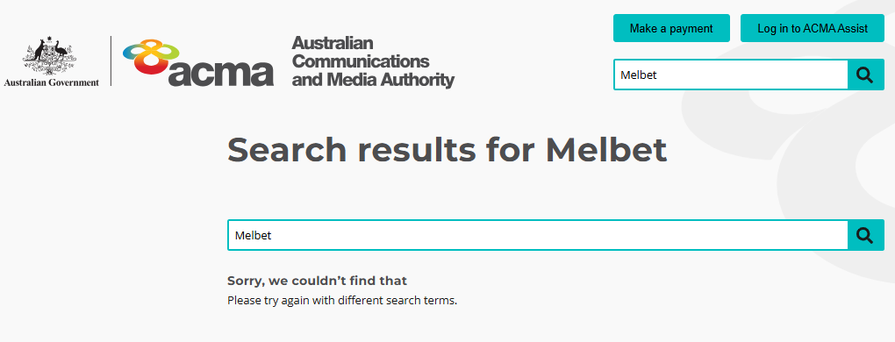
Figure 19: Trustpilot page for Melbet showing a warning that the rating is unavailable due to a breach of guidelines and that fake reviews were removed | Figure 20: ACMA site search for "Melbet" returning no results (a site search, not the blocked-sites register)

9. References
Allaxess. (2026, May 1). Licensed MelBet platform and its impact on sports betting markets. https://allaxess.com/how-licensing-changed-melbets-place-in-sports-betting/
Australian Communications and Media Authority. (2024, May). ACMA blocks more illegal gambling websites. https://www.acma.gov.au/articles/2024-05/acma-blocks-more-illegal-gambling-websites
Australian Communications and Media Authority. (n.d.). Blocked gambling websites. Retrieved 21 September 2026, from https://www.acma.gov.au/blocked-gambling-websites
BetLuma. (2026, June). MelBet review 2026: Bonus, payments, licence & safety. https://betluma.com/reviews/melbet-casino
Football Whispers. (2026, June 1). Melbet review 2026 – Is it really safe to bet in Bangladesh? https://footballwhispers.com/blog/melbet-review/
Goal.com India. (2026). MelBet review and expert ratings for India (2026). https://www.goal.com/en-in/betting/melbet-review/blt14d2000a2afd9e15
International Masters of Gaming Law. (2026). What India's new regulations mean for online gaming. IMGL Magazine, 3(1). https://www.imgl.org/publications/imgl-magazine-volume-3-no-1/what-indias-new-regulations-mean-for-online-gaming/
Langham, E., Thorne, H., Browne, M., Donaldson, P., Rose, J., & Rockloff, M. (2016). Understanding gambling related harm: A proposed definition, conceptual framework, and taxonomy of harms. BMC Public Health, 16, Article 80. https://doi.org/10.1186/s12889-016-2747-0
Lexology. (2025, September 1). Behind the ban: The Promotion and Regulation of Online Gaming Act, 2025. https://www.lexology.com/library/detail.aspx?g=67f5157a-fefc-4836-9f9f-97987c0174da
Lexology. (2026, May 6). Setting the rules of the game: India's online gaming law comes into force. https://www.lexology.com/library/detail.aspx?g=29103459-cefe-4528-a762-dbd53ce6979e
Press Information Bureau. (2026). Promotion and Regulation of Online Gaming Rules, 2026 [Press release]. https://www.pib.gov.in/PressReleasePage.aspx?PRID=2256973&reg=3&lang=2
Promotion and Regulation of Online Gaming Act 2025 (India). Ministry of Electronics and Information Technology. https://www.meity.gov.in/static/uploads/2025/10/8a7f103cefc68ed8aaa2ebc9a2ed7c13.pdf
Telecom Asia. (n.d.). Melbet India review 2026: Sports betting, casino & app guide. https://www.telecomasia.net/in/sports-betting/reviews/melbet/
The Hans India. (2025, July 15). Melbet Bangladesh review: Legal info, games & payments. https://www.thehansindia.com/games/melbet-bangladesh-review-legal-info-games-payments-988165
Trustpilot. (2026a). Melbet reviews: Read customer service reviews of m.melbet.com. Retrieved 21 September 2026, from https://www.trustpilot.com/review/m.melbet.com
Trustpilot. (2026b). Melbet reviews: Read customer service reviews of www.melbet.com. Retrieved 21 September 2026, from https://www.trustpilot.com/review/www.melbet.com

